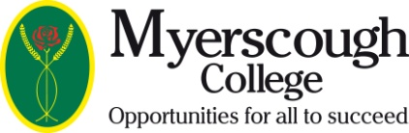

Employer Confirmation of Responsibility for Student Fees
If your employer is to be invoiced for your course, please ensure the sections below are completed and returned to the Finance Office at the College before you enrol.
Student’s Name:
Course Title:
Course Start Date: |  |  |  |  |  | Expected Completion Date:
Employer/Company name:
Address:
 |  |  |  |  |  |  |  | Postcode:

Email Address:

Telephone Number:
Contact Name (Block capitals):
I confirm that the above named company will pay all fees as indicated below in respect of the above named student. Please authorise with the Company stamp and purchase order number if required.

 |  |  |  |  |  |  | Company Stamp
 | Facilities and Resources Contribution
 | Tuition Fees
 | Residential Fees
 |  |  |  |  |  |  | Purchase Order Number:
Authorised Signature:
Name (Block capitals):
Position:
Date:
Please return completed forms to
Finance Office
Myerscough College
St Michaels Road
Billsborrow
Preston
PR3 0RY

Email: salesledger@myerscough.ac.uk
Fax: 01995 642137

