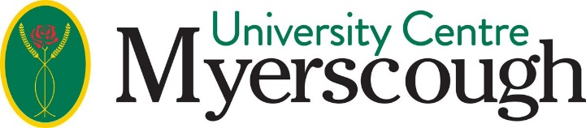

COVID-19 (Coronavirus) Information for September 2020 for Applicants and those holding Unconditional or Conditional offers
I hope you are managing to stay safe and well during the current situation we all find ourselves in. This email contains some important information about how exam cancellations and measures put in place by the Government may affect your application, what action we are taking and how to keep in touch with us. Please be assured that we are still processing applications and making arrangements for your place on a degree course with us for 2020-21.

A summary of the facts:
- GCSEs A-Levels, BTECs and other examinations will not be taking place this summer.
- The Government has assured students that they will still receive their qualifications and be able to continue to progress with their studies.
- International applications are however being disrupted. Individual countries are making final decisions on how they will address the issue of exams.
A general update and response from University Centre Myerscough on applications can be found here

Entry criteria
Our approach as to how we will progress applications will consider the following:
- Advice from the Office for Students that has emphasised the importance of consideration of applicants from disadvantaged backgrounds who may be affected by the current situation.
- Reassurance from the Government, that it is committed to ensuring there are no barriers which may stop candidates achieving the qualifications they need to progress to Further or Higher Education in the next academic year.
- A review of requirements for work experience and work placements.
- Advice from the professional bodies that we work with to ensure they are prepared to accept the changes.
Once we have the confirmed information and have made a decision on any adjustments (that may or may not be required) to our entry criteria, we will publish it on this page and advise all affected applicants directly.

How will grades from my current course be calculated?
It is expected that teachers in UK Schools and Colleges will calculate A Level, BTEC, City & Guilds and GCSE grades based upon advice and guidance provided by Ofqual. These grades are expected to be confirmed by the examination boards and made available to students during the summer. You should contact your Institution/School/College directly for more information.

HE Full time applicants Important Information
The Office for Students (OfS) has introduced an enforced delay on unconditional offer making.
- From 30 March 2020 until 13 April 2020, Universities and Colleges will not be permitted to make any unconditional offers to Higher Education full time applicants. This is to ensure fairness for all students during this period of uncertainty. Please note, this only applies to new unconditional offers. If you already have an offer with us, your offer still stands.
- UCAS have also extended their reply deadlines by two weeks, giving you additional time to consider any actions.
- It is important to remember that this government guidance is only for 2 weeks so we are advising applicants not to make any sudden decisions during this period.
- We will follow Government guidelines and provide further details as soon as they are available.
Please be assured that we will continue to provide you with an opportunity to study on a degree programme with us where possible.

How to contact us
During the period of enforced social distancing, the Student Admissions Team will be working remotely from home, processing your application and making decisions. You will not be able to contact us on the telephone directly, but you can speak to us on our website via Live Chat (Monday to Thursday, 9am to 5pm and Friday 9am until 4.30pm).
Alternatively, you can email enquiries@myerscough.ac.uk
FAQs and other important information can be found on the HE Full Time Admissions Guide

